**IS Assignment # 1**

**Roll no: 20K-0409**

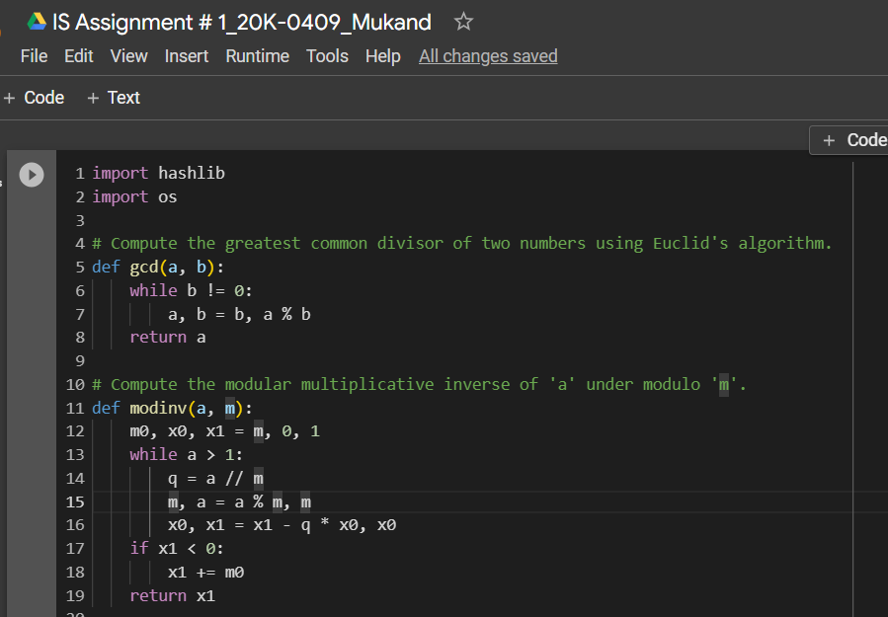**Screen shots:**

**RSA Signature:**

**Encrypt and Decrypt:**

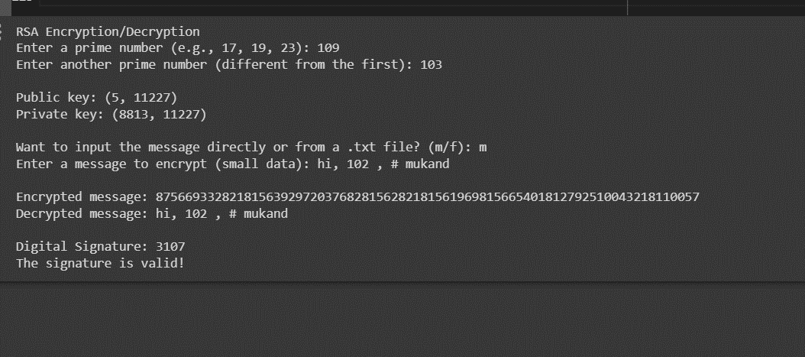**Output:**

**Input from file:**

